Power BI Assignment 2 – DAX & Data Visualization

Calculated Columns:
1.Create a Calculated Column for 'Category Type': Add a calculated column in the Order Details table that combines the 'Category' and 'Sub-Category' columns into a single 'Category Type' column.
Category Type =
VAR Cat = 'Order Details'[Category]
VAR SubCat = 'Order Details'[Sub-Category]
RETURN
TRIM ( Cat & " - " & SubCat )

2.Calculate Revenue per Order in Order Details Table: Create a calculated column in the Order Details table to compute the revenue (Amount * Quantity) per order.

Revenue per Order = 'Order Details'[Amount] * 'Order Details'[Quantity]

3.Create a Calculated Column to Categorize Sales: Add a calculated column named ‘Sales Category’ in the Order Details table that categorizes each order as 'Above Average' or 'Below Average' based on the Amount value.
Sales Category = VAR AvgAmountAll =
CALCULATE ( AVERAGE ( 'Order Details'[Amount] ), ALL ( 'Order Details' ) )
RETURN
IF ( 'Order Details'[Amount] >= AvgAmountAll, "Above Average", "Below Average" )

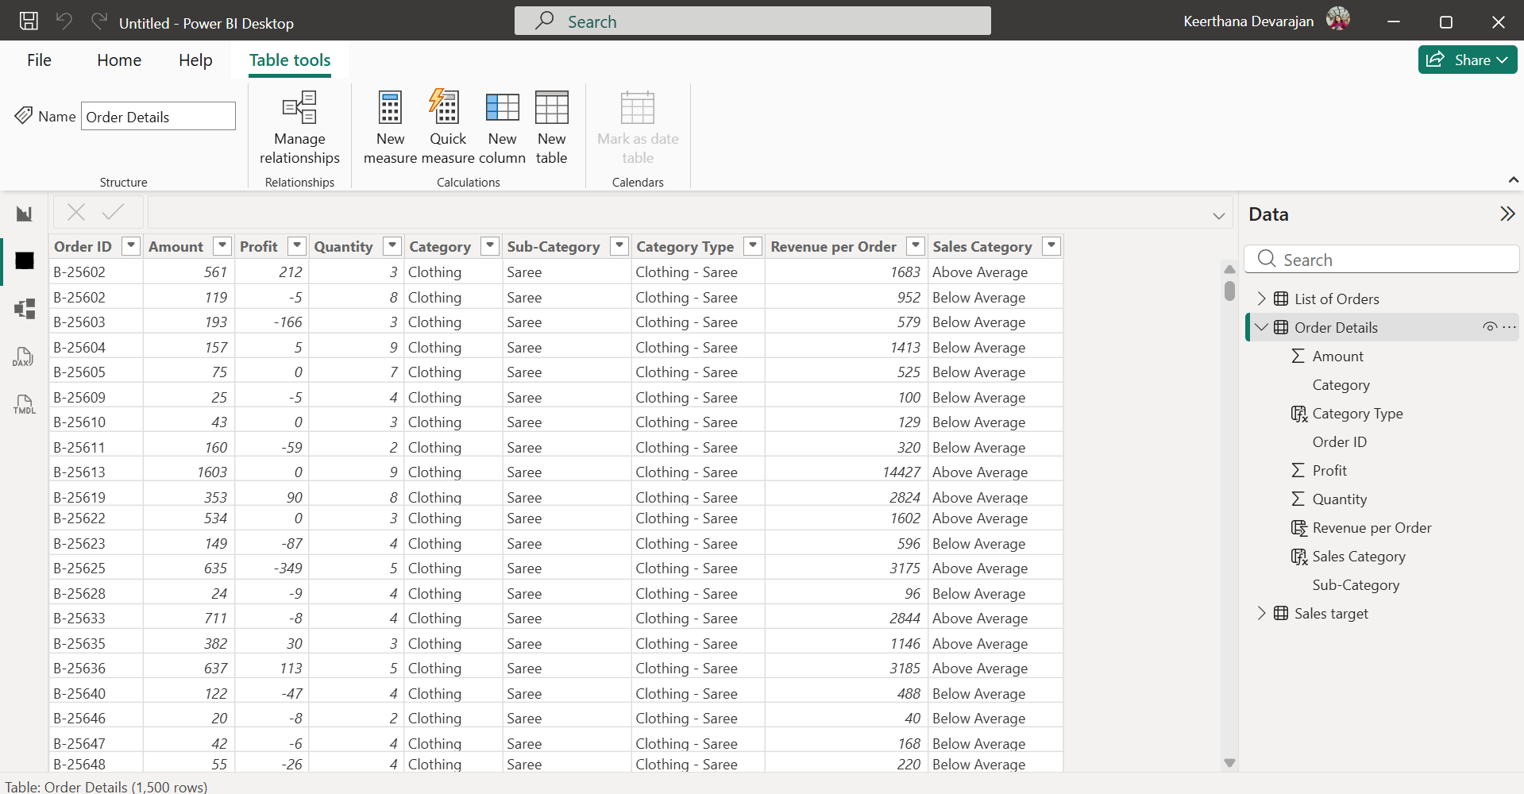
Calculated Measures:
1.Calculate Order Count: Define a measure to count the total number of orders in the Order Details table.
Order Count = COUNTROWS ('Order Details')

2.Calculate Average Profit in Delhi: Create a measure to calculate the average profit for orders placed in Delhi.
Average Profit (Delhi) =
CALCULATE (
AVERAGE ( 'Order Details'[Profit] ),
'List of Orders'[City] = "Delhi"
)

3.Calculate Year-to-Date (YTD) Sales: Define a measure to calculate the total sales amount accumulated from the earliest order date up to each order date.

YTD Sales =
TOTALYTD (CALCULATE(SUM('Order Details'[Amount])),'Calendar'[Date])

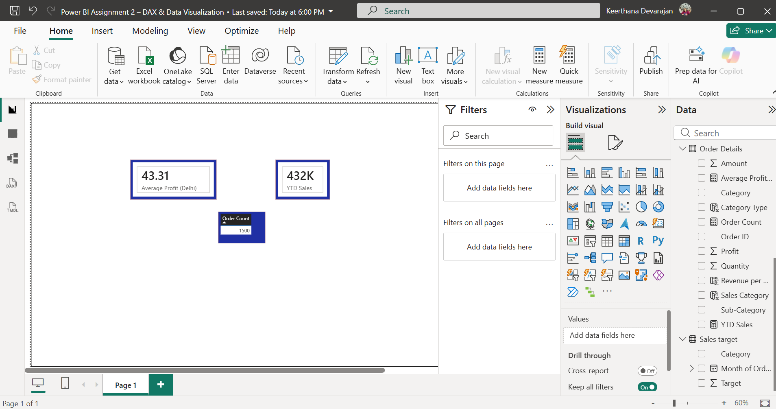

Data Visualization:
1.Sales Target Achievement by Category: Compare actual sales with sales targets by category using a clustered column chart.
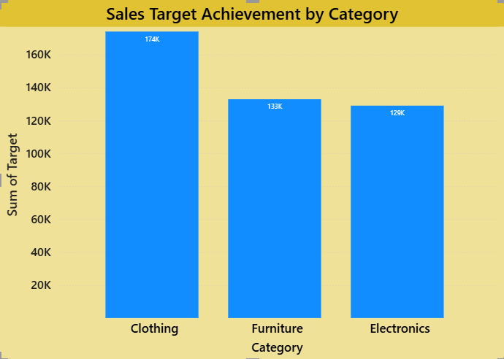

2.Max Profit Margin by Sub-Category: Analyze the maximum profit margin for each sub-category of products using a donut chart.
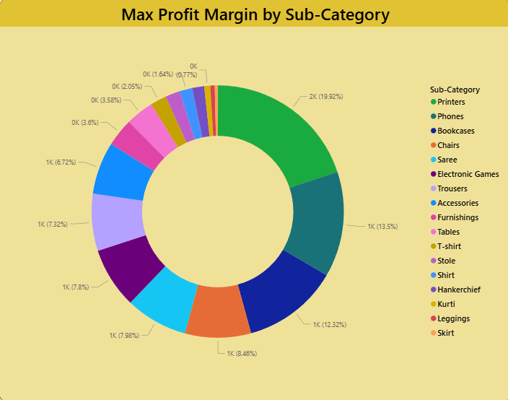

3.Monthly Sales Trend: Show the trend of monthly sales over time using a line chart.
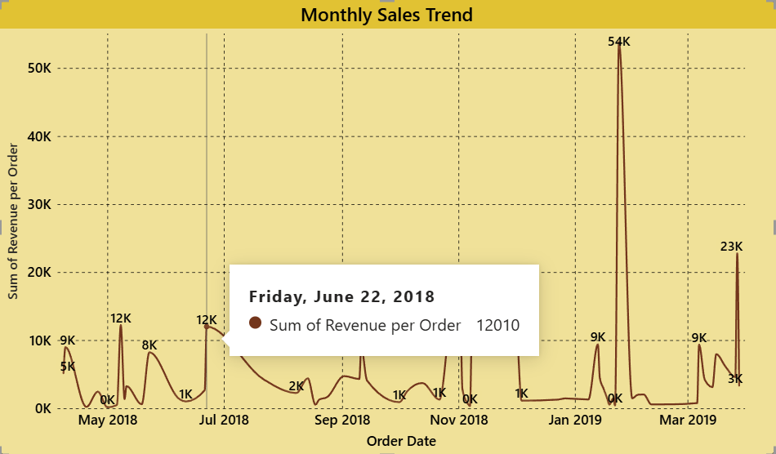

4.Comparison of Profit and Quantity by Sub-Category: Compare the relationship between profit and quantity sold for different sub-categories using a scatter chart.
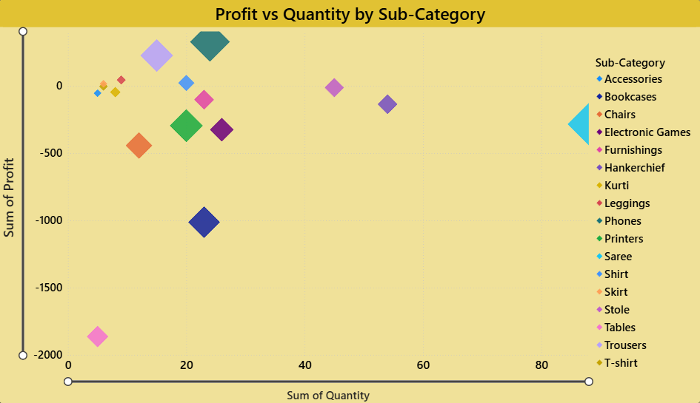
5.Comparison of Total Sales Amount and Target: Create cards to succinctly display the total sales amount alongside the sales target for quick comparison and analysis. Also, create a multi-row card to display the minimum target for each segment.
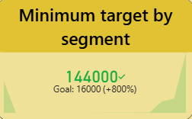
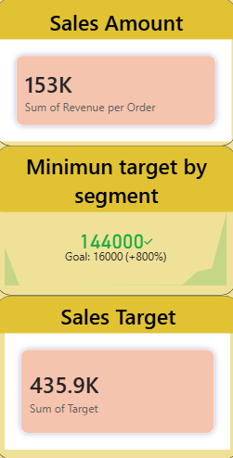

6.Sales Performance Matrix: Build a matrix view to analyze how actual sales compare to sales targets across different categories and months.
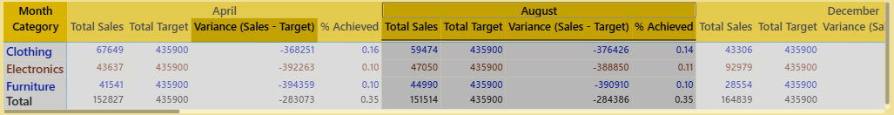

7.Geographic Sales Analysis: Visualize total sales on a map by city to identify regional sales patterns.
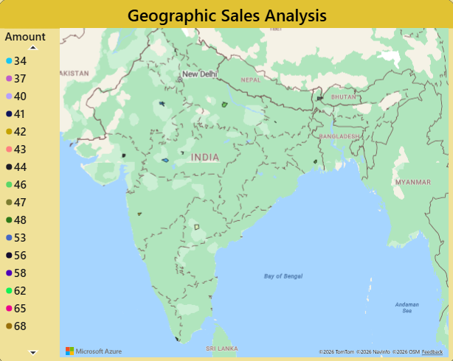

8.Sales Distribution by Sub-Category: Represent the sales distribution across different sub-categories using a treemap.

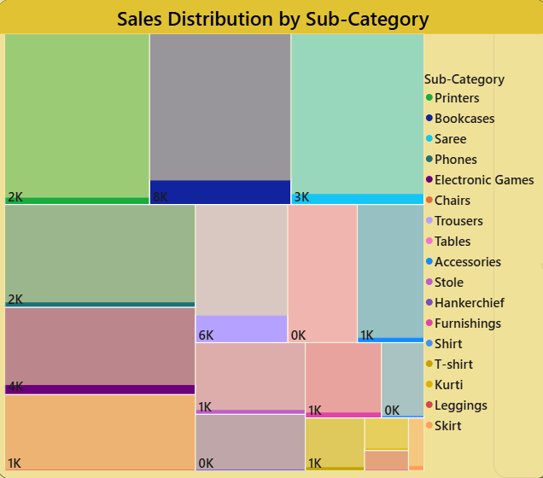

9.Order Count Analysis by State: Create a funnel chart to visualize the distribution of order counts across different states.

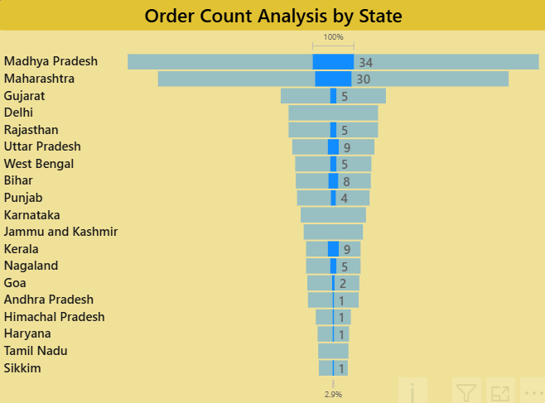

Complete Data Visualization Dashboard
